PROFORMA FOR MANDATORY DISCLOSURE OF INFORMATION ABOUT ACCREDITED PROGRAMMES BY INSTITUTIONS TO BE INCLUDED IN THEIR RESPECTIVE INFORMATION BROCHURE, DISPLAYED ON THEIR WEBSITE AND TO BE SUBMITTED TO NBA EVERY YEAR WELL BEFORE THE ADMISSION PROCESS

The following information is to be published in the Information Brochure besides being hosted on the Institution’s official Website as fixed content.

Name of the Programme : M.B.A

Approved Intake : 60

Fees charged (per annum) in Rs. : Rs. 25,000/=

Pass percentage during the last 5 years : 86.47%

Teacher Student Ratio : 15 : 1

No. of Faculty Members :

Cadre Number

Professor : 3
Asst. Professor : 3
Lecturer : 4

Faculty Profile :

Qualification No. of Faculty

Ph.D. : 1
Post Graduate : 10
Under Graduate : Nil

Experience of Faculty :

Number of Faculty with

Less than 5 years : 5
5 to 10 years : 1
More than 10 years : 4

Details of individual faculty members :

Name, Photograph, Date of Birth,
Qualifications, Professional Experience,
Research Interests.

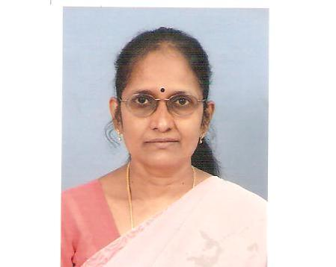

1. Name : Rajeswari Krishnan

- Date of Birth : 15.07.56

3. Educational Qualification : M.Sc Phy, M.B.A, M.Phil
Ph.D

4. Work Experience
- Teaching : 9 Years and 01 Months
- Research : --
- Industry 21 years
- Others ---

5. Area of Specializations : Finance & HRM

6. Subjects teaching at
Under Graduate Level : NIL

Post Graduate Level

Financial and Management Accounting.

7. Research guidance
No. of papers published in

Master’s - National Journals
Ph.D. - International Journals
- Conferences

8. Projects Carried out : --

9. Patents : --

10. Technology Transfer : --

11. Research Publications : --

12. No. of Books published with details : --

      - Name : Prof. Jagatha Lakshmanan

      - Date of Birth : 05.03.1949

      - Educational Qualification : M.A. M.Phil (Ph.D)

      - Work Experience
- Teaching : 36 Years and 02 Months
- Research : M.Phil.
- Industry ---
- Others ---

5. Area of Specializations : Economics

6. Subjects teaching at
Under Graduate Level : NIL

Post Graduate Level

Managerial Economics

7. Research guidance
No. of papers published in

Master’s - National Journals
Ph.D. - International Journals
- Conferences

8. Projects Carried out : --

9. Patents : --

10. Technology Transfer : --

11. Research Publications : --

12. No. of Books published with details : --

1. Name : Prof. C.V. Kulandaivelu

2. Date of Birth : 01.01.1945

3. Educational Qualification : M.A. M.Phil., Ph.D

4. Work Experience
- Teaching : 39 Years
- Research : M.Phil.
- Industry ---
- Others ---

5. Area of Specializations : Economics

6. Subjects teaching at
Under Graduate Level : NIL

Post Graduate Level

Executive Communication

- Research guidance
No. of papers published in

Master’s - National Journals
Ph.D. - International Journals
- Conferences

8. Projects Carried out : --

9. Patents : --

10. Technology Transfer : --

11. Research Publications : --

12. No. of Books published with details : --

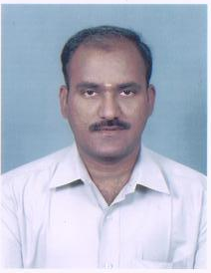

1. Name : M. Velumani

- Date of Birth : 05.06.1976

- Educational Qualification : M.B.A. M.Com.,

4. Work Experience
- Teaching : 10 Years and 06 Months
- Research : Undergoing M.Phil.
- Industry ---
- Others ---

5. Area of Specializations : Dual

6. Subjects teaching at
Under Graduate Level : NIL

Post Graduate Level

Services Marketing

7. Research guidance
No. of papers published in

Master’s - National Journals
Ph.D. - International Journals
- Conferences

8. Projects Carried out : --

9. Patents : --

10. Technology Transfer : --

11. Research Publications : --

12. No. of Books published with details : --

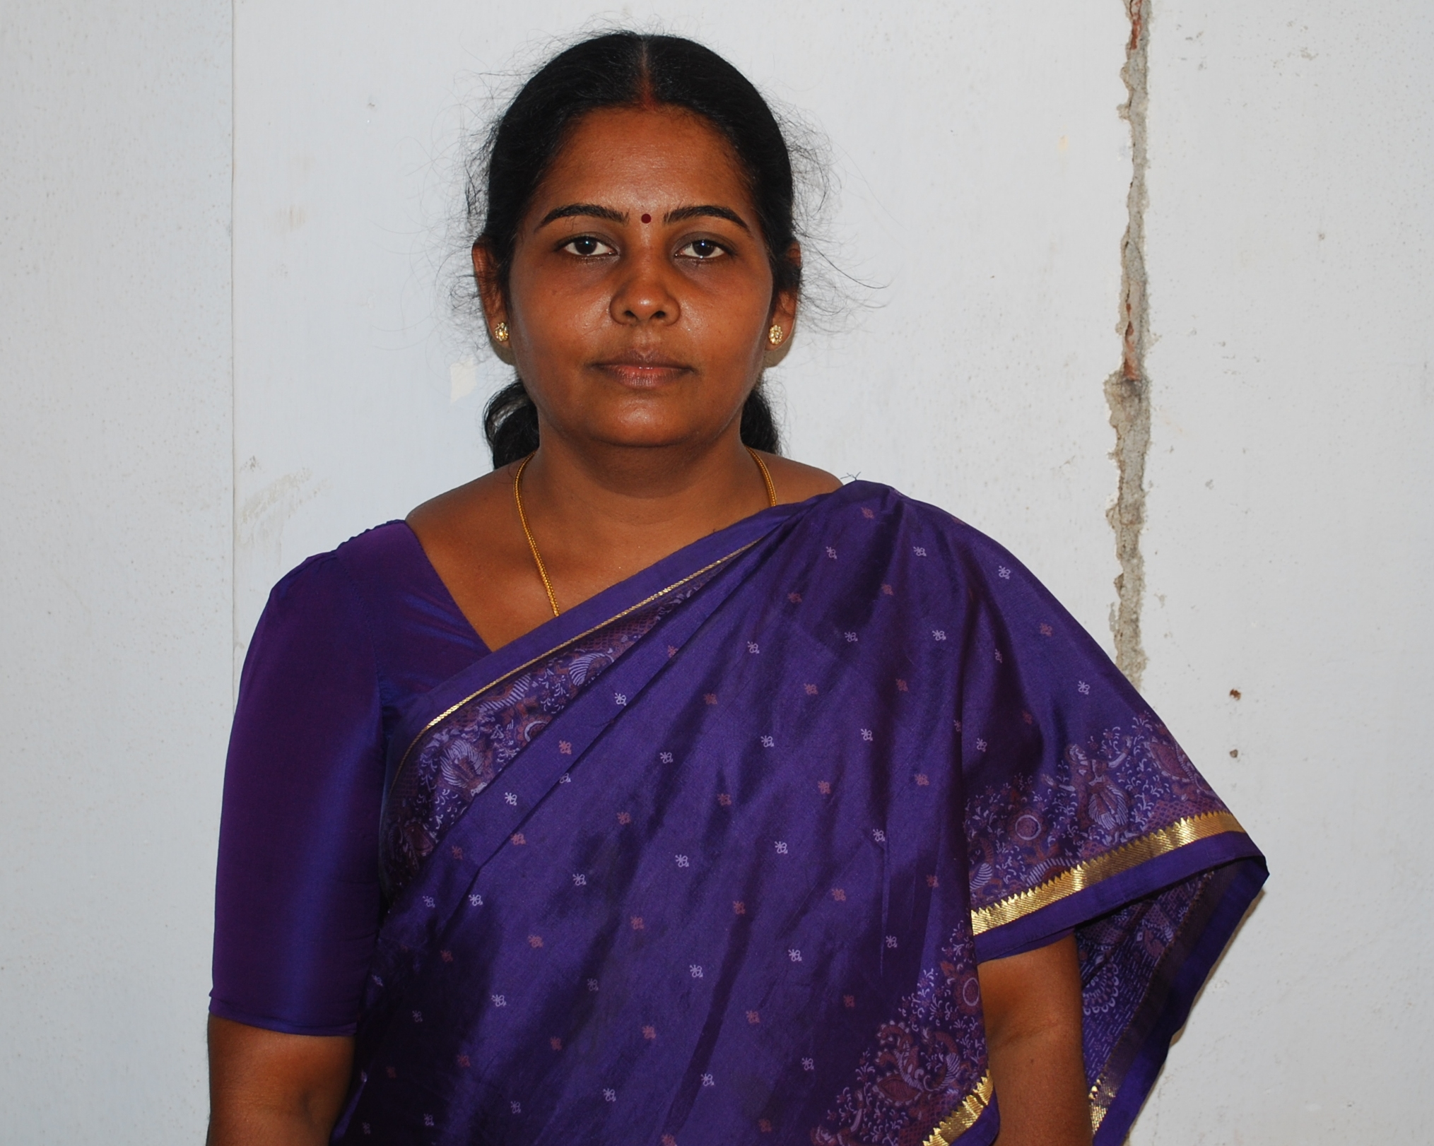
1. Name : C.Dhanalakshmi

- Date of Birth : 07.05.1965

- Educational Qualification : M.Com., M.Phil.,PGDCA

4 Work Experience
- Teaching : 11Years and 1 Month
- Research : M.Phil.
- Industry ---
- Others ---

5. Area of Specializations : Financial Management

6. Subjects teaching at
Under Graduate Level : NIL

Post Graduate Level

Financial Services
Financial Management
7. Research guidance

No. of papers published in
Master’s - National Journals 4
Ph.D. - International Journals
- Conferences
Papers presented in National Level 18
International Level 02

8. Projects Carried out : --

9. Patents : --

10. Technology Transfer : --

11. Research Publications : --

12. No. of Books published with details : --


1. Name : S.Thiriveni Sripriya

- Date of Birth : 08.05.1984

3. Educational Qualification : M.B.A.,M.Phil.,

4. Work Experience
- Teaching : 06 Months
- Research : ---
- Industry 2 years
- Others ---

5. Area of Specializations : Marketing & HRM

6. Subjects teaching at
Under Graduate Level : NIL

Post Graduate Level

Strategic Management
Human Resource Development

7. Research guidance
No. of papers published in

Master’s - National Journals Nil
Ph.D. - International Journals Nil
- Conferences
Papers presented in National Level 02
International Level Nil

8. Projects Carried out : --

9. Patents : --

10. Technology Transfer : --

11. Research Publications : --

12. No. of Books published with details : --

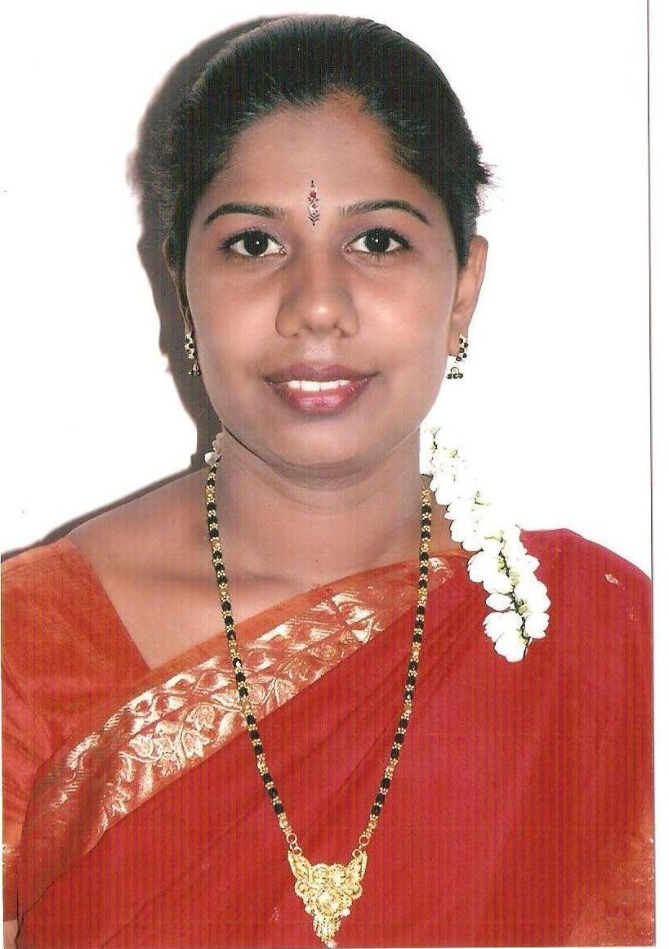
1. Name : M. Shakunthaladevi

- Date of Birth : 29.01.1982

3. Educational Qualification : M.B.A.

4. Work Experience
- Teaching : 3 Years and 01 Months
- Research : Pursuing M.Phil.
- Industry ---
- Others ---

5. Area of Specializations : HRM & Marketing

6. Subjects teaching at
Under Graduate Level : NIL

Post Graduate Level

Marketing Management
Business Environment

7. Research guidance
No. of papers published in

Master’s - National Journals
Ph.D. - International Journals
- Conferences

8. Projects Carried out : --

9. Patents : --

10. Technology Transfer : --

11. Research Publications : --

12. No. of Books published with details : --



1. Name : P.Sathya Kiruba

- Date of Birth : 21.05.1982

3. Educational Qualification : M.B.A. M.Phil.,MHRM

4. Work Experience
- Teaching : 3 Years and 03 Months
- Research : M.Phil.
- Industry ---
- Others ---

5. Area of Specializations : HRM & Marketing

6. Subjects teaching at
Under Graduate Level : NIL

Post Graduate Level

Managing Interpersonal Effectiveness
Equity Research & Portfolio Management

7. Research guidance
No. of papers published in

Master’s - National Journals
Ph.D. - International Journals
- Conferences

8. Projects Carried out : --

9. Patents : --

10. Technology Transfer : --

11. Research Publications : --

12. No. of Books published with details : --

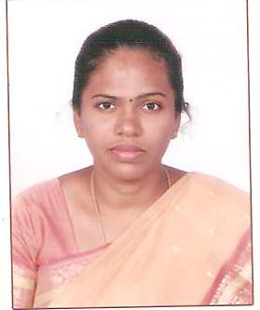
1. Name : P.Nalini

2. Date of Birth : 15.11.1982

3. Educational Qualification : M.B.A. M.Phil.,MMM

4 Work Experience
- Teaching : 3 Months
- Research : M.Phil.
- Industry ---
- Others ---

5. Area of Specializations : HRM & Marketing

6. Subjects teaching at
Under Graduate Level : NIL

Post Graduate Level

Management Process
Promotional Management

7. Research guidance
No. of papers published in

Master’s - National Journals
Ph.D. - International Journals
- Conferences

8. Projects Carried out : --

9. Patents : --

10. Technology Transfer : --

11. Research Publications : --

12. No. of Books published with details : --

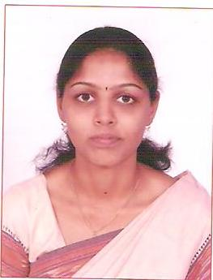

1. Name : T.S.Janani

- Date of Birth : 27.08.1985

3. Educational Qualification : M.B.A.,

4. Work Experience
- Teaching : 03 Months
- Research : ---
- Industry ---
- Others ---

5. Area of Specializations : HRM & Marketing

6. Subjects teaching at
Under Graduate Level : NIL

Post Graduate Level

Consumer Behaviour

7. Research guidance
No. of papers published in

Master’s - National Journals Nil
Ph.D. - International Journals Nil
- Conferences
Papers presented in National Level 02
International Level Nil

8. Projects Carried out : --

9. Patents : --

10. Technology Transfer : --

11. Research Publications : --

12. No. of Books published with details : --

Industrial Consultancy, Research and Development (during the past 5 years):

Amount of Industrial Consultancy earned (in lakhs of Rupees) | :
No. of sponsored research projects completed | : | --
No. of patents produced | : | --
No. of sponsored research projects in progress | : | --
No. of papers published in International journals | : | --
No. of papers published in National journals | : | 04
No. of papers presented in International Conferences / Seminars | : | 02
No. of papers presented in National Conferences / Seminars | : | 18
No. of International Conferences conducted | : | --
No. of National Conferences conducted | : | --
No. of Training Programmes / Short Term Courses conducted |  | --

Placement Record for the previous year:

No. of Companies who visited the Campus | : | 7
Names and Details of companies who visited the campus  along with No. of Students placed | : | List enclosed
No. of Students placed through campus recruitment | : | 142
Maximum salary drawn (in Rs.) | : | Rs.18,750/=
Average salary drawn (in Rs.) | : | Rs. 13,375/=

Budget Allocation for the Programme (in Rs.) :

Recurring : 30.53

Non Recurring : 04.00

New initiatives and future vision, if any : 100% Placement for all M.B.A. Students

Note: Suppression and/or misrepresentation of information would attract appropriate penal action.

